**Tarea 00 – Nombre Tarea**

Nombre alumno

Pontificia Universidad Católica

***Motivación* – Hello, here is some text without a meaning. This text should show what a printed text will look like at this place. If you read this text, you will get no information. Really? Is there no information? Is there a difference between this text and some nonsense like “Huardest gefburn”? Kjift – not at all!**

1. SOLUCIÓN PROPUESTA

Hello, here is some text without a meaning. This text should show what a printed text will look like at this place. If you read this text, you will get no information. Really? Is there no information? Is there a difference between this text and  
some nonsense like “Huardest gefburn”? Kjift – not at all! A blind text like this gives you information about the se- lected font, how the letters are written and an impression of the look. This text should contain all letters of the alphabet  
and it should be written in of the original language. There is no need for special content, but the length of words should match the language This is the second paragraph. Hello, here is some text with-  
out a meaning. This text should show what a printed text Will look like at this place. If you read this text, you will get no information. Really? Is there no information? This text should contain  
all letters of the alphabet and it should be written in of the original language. There is no need for special content, but the length of words should match the language. And after the second paragraph follows the third paragraph.  
Hello, here is some text without a meaning. This text should show what a printed text will look like at this place. If you read this text, you will get no information. Really? Is there no information? Is there a difference between this text and  
some nonsense like “Huardest gefburn”? Kjift – not at all!

1. EXPERIMENTOS REALIZADOS

Hello, here is some text without a meaning. This text should show what a printed text will look like at this place. If you read this text, you will get no information. Really? Is there no information? Is there a difference between this text and

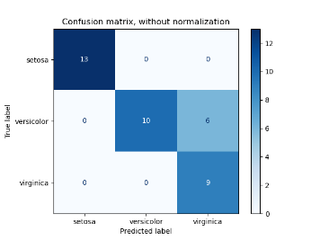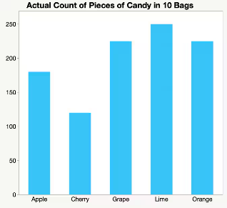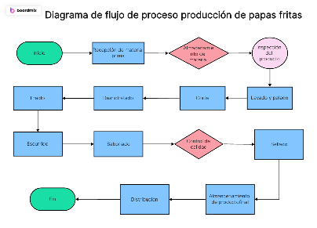some nonsense like “Huardest gefburn”? Kjift – not at all! A blind text like this gives you information about the se- lected font, how the letters are written and an impression of the look. This text should contain all letters of the alphabet and it should be written in of the original language. There is no need for special content, but the length of words should match the language This is the second paragraph. Hello, here is some text with-out a meaning.

Figure 1: matriz confusión

Figure 2: gráfico cualquiera

Figure 3: Diagrama de flujo

1. CONCLUSÓN

Hello, here is some text without a meaning. This text should show what a printed text will look like at this place. If you read this text, you will get no information. Really? Is there no information? Is there a difference between this text and  
some nonsense like “Huardest gefburn”? Kjift – not at all! A blind text like this gives you information about the se- lected font, how the letters are written and an impression of the look. This text should contain all letters of the alphabet  
and it should be written in of the original language.